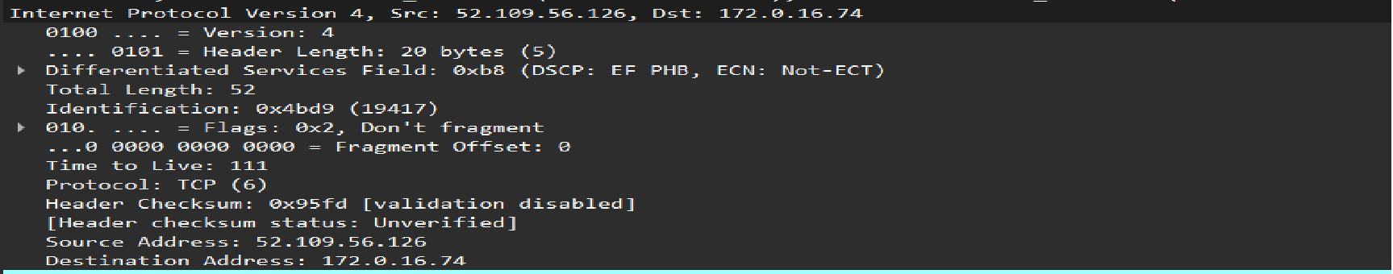
1) Version(4 bits) → It means the ip version is 4 i.e. ipv4

2) Header Length : 20 bytes(5) → 4-byte words is present in header file and 5 represent the header is 20 bytes long (5*4 byte)
→ Each word represent 32 bit i.e. 1 word = 32 bit…….ipv4 consist 20 – 60 byte..

3) Differentiated services code point(DSCP) → Real-time data streaming makes use of the DSCP field. It is a 6 bit field and it shows there is use of DSCP where value is b8..
4)Explicit Congestion Notification (ECN) → This field allow end-to-end notification of network congestion without dropping packets. The value form the above picture says there is no use of ECN.
3) Total Length(2 bytes): 52 → 52 byte of packet has been capture including the header for this case

4)Identification Number(2 byte) value:0x4bd9 indicate the identification value of this packet

5)Protocol: tcp(6) → This packet is described in form of tcp ip layer.

3)Header checksum (2 byte) ; value = 0x95fd→ It indicate the sent packets and received packets are same or not and If not same, the some data has been lost…

4) source address(4byte); value = 52.109.56.126 → It give the ip address of sender that indicate the address has been sent from the given address

5)Destination address(4byte): value = 172.0.16.74 → It give the ip address of destination that indicate the address where the data is supposed to reach

Notes::→
The IPv4 packet header consists of 14 fields(60 bytes), of which 13 are required(only 20 bytes are required)

